A PROJECT REPORT

on

“AI-Enabled FinTech B2B Invoice Management Application”

Submitted to

KIIT Deemed to be University

In Partial Fulfillment of the Requirement for the Award of

BACHELOR’S DEGREE IN

COMPUTER SCIENCE AND ENGINEERING

BY
SUBHADEEP MONDAL (1905829)

UNDER THE GUIDANCE OF

TUSHAR DEEPAK & RAUSHAN KUMAR
Affiliation


SCHOOL OF COMPUTER ENGINEERING

KALINGA INSTITUTE OF INDUSTRIAL TECHNOLOGY

BHUBANESWAR, ODISHA - 751024

APRIL 2022

A PROJECT REPORT

on

“AI-Enabled FinTech B2B Order Management Application”

Submitted to

KIIT Deemed to be University

In Partial Fulfillment of the Requirement for the Award of

BACHELOR’S DEGREE IN INFORMATION TECHNOLOGY

BY

SUBHADEEP MONDAL

UNDER THE GUIDANCE OF

TUSHAR DEEPAK & RAUSHAN KUMAR
Affiliation

SCHOOL OF COMPUTER ENGINEERING

KALINGA INSTITUTE OF INDUSTRIAL TECHNOLOGY

BHUBANESWAE, ODISHA -751024

APRIL 2022

KIIT Deemed to be University

School of Computer Engineering
Bhubaneswar, ODISHA 751024

CERTIFICATE

This is certify that the project entitled

“AI-Enabled FinTech B2B Order Management Application“

submitted by

SUBHADEEP MONDAL (1905829)

is a record of bonafide work carried out by them, in the partial fulfillment of the requirement for the award of Degree of Bachelor of Engineering (Computer Sci-ence & Engineering OR Information Technology) at KIIT Deemed to be university, Bhubaneswar. This work is done during year 2022-2023, under our guidance.

Date: 15/04/2022

TUSHAR DEEPAK & RAUSHAN KUMAR
Project Mentor

Acknowledgements

We are profoundly grateful to TUSHAR DEEPAK & RAUSHAN KUMAR of HighRadius for his expert guidance and continuous encouragement throughout to see that this project rights its target since its commencement to its completion. .....................

SUBHADEEP MONDAL

ABSTRACT

The B2B world operates differently from the B2C or C2C world. Businesses work with other businesses on credit. When a buyer business orders something from the seller business, the seller business issues an invoice for that order. This invoice contains various information like the details of the goods purchased and when they should be paid. Seller business interacts with various businesses and sells goods to all of them at various times. Hence, the seller business needs to keep track of the total amount it owes from all the buyers. This involves keeping track of all invoices from all the buyers.

The buyer business needs to clear its amount due before the due date. However, in real-world scenarios, the invoices are not always cleared i.e. paid in full amount by the due date. So my project should help the Account Receivables team by collecting payments from customers for their past dues, sending reminders and follow-ups to the customers for payments to be made, and help the company get paid for the services and products supplied.

Keywords: Account Receivables, B2B, Invoice manager, C2C, AI enabled

Contents

1 | Introduction |  |  | 1
 | 1.1 | AI-Enabled FinTech B2B Order Management Application
 |  | 1.1.1 | Introduction
 |  | 1.1.2 | Overview
 |  | 1.1.3 | Problem Definition
 |  | 1.1.4 | Purpose
 |  | 1.1.5 | Scope
 |  | 1.1.6 | Definition, Acronyms & Abbreviations
2 | Basic Concepts |  |  | 2
 | 2.1 | Basic idea of the project |  | 2
 |  | 2.1.1 | Domain covered
 |  | 2.1.2 | Technology used
 |  | 2.1.3 | The idea behind the project
3 | Project Analysis / Project Implementation |  |  | 4
 | 3.1 | Project Implementation |  | 4
4 | Results & Discussions |  |  | 4
 | 4.1 | Result |  | 4
5 | Conclusion & Further Work
 | 5.1 | Conclusion
 | 5.2 | Future Work

List of Figures

1.1 | Working of a Random Forest Algorithm | 2
1.2 | Working of Linear Regression | 9
1.3 | Working of Decision Tree
1.4 | Working of SVM
1.3 | Working of XGBoost Regressor
1.3 | Connection of JDBC with Database with the help of Java
1.5 | Working of ML Model
1.6 | The average delay for customers from different business codes
1.7 | Total_open_amount distribution curve
1.9 | Delay Distribution Curve
1.10 | Log Transformation of total open amount curve
1.11 | scatterplot between total_open_amount and target_value
1.12 | Heatmap of train dataset
1.13 | Workflow of Java and ReactJS
1.14 | ML Accuracy Result
1.15 | Bucketization
1.16 | SQLyog
1.17 | Servlet Mapping
1.18 | Main UI
1.19 | Active Buttons
1.20 | Add Order Button
1.21 | View Correspondence Button
1.22 | Edit Button
1.23 | Delete Button
1.24 | Predict Button
1.25 | Working of Flask Server
1.26 | Gaant Chart for project planning and management

School of Computer Engineering, KIIT, BBSR
AI-Enabled FinTech B2B Order Management Application

Chapter 1

Introduction

1.1 AI-Enabled FinTech B2B Order Management Application

1.1.1 Introduction

An Order Management System is a computer software program that allows businesses to
manage their orders and inventory. The Order Management system ensures accurate
inventory management by automating the process of entering new inventory. It also tracks
sales from various e-commerce platforms such as eBay, Amazon, etc, and informs the owner
of the stock of a particular product stoop below the threshold. It automates the entire process
of order to cash i.e. order placement, payment reconciliation, fulfillment, and shipment.

Order management software is also shareable, from the customer service team to the
accounting team, the warehouse staff, and the business owner. The best kinds of inventory
management systems also have an order management app, allowing you to manage your
stock on the go and spot-check your business in real-time. Effective order management improves the business workflow and increases the likelihood of repeat customers.

      - Order Management System

The Order Management system goes through 6 steps to ensure accurate process and
fulfillment of orders placed by the customer. It covers every aspect starting from entering
invoices to sales follow-up. The seamless flow of the software ensures faster delivery.

● The order is placed: The customer places an order through a third-party sales site, or
the owner’s website, or over the phone with a live representative. Online, your
customers will enter their details on a uniform form, with a choice to have a securely
saved preferred payment method. To improve the sales process, make all fields of
your online form mandatory so that you've got all the required contact information for
the customer up-front. This creates a customer profile and allows your order
management system to trace their purchase history, the number of orders, and
payment and delivery preferences. This process ensures that the phone number or
email id is saved for any follow-up processes or service recovery. The payment is
processed, then the order is shipped to the warehouse once your software approves.

● Warehouse processing: Once the order arrives at the warehouse, it's checked by the
intake team and therefore the item or items are "picked" from the stock. Having an
SKU and barcode for each item increases the accuracy of fulfillment and makes it
easier for pickers to easily scan the item and add it to the order. If there's not enough of the item(s) available to satisfy an order, then a sale order is
automatically placed through the order management software.

School of Computer Engineering, KIIT, BBSR

AI-Enabled FinTech B2B Order Management Application

● Reconciling the order: Next, the order is shipped to the accounting department or preferably it should sync automatically together with cloud accounting software, where it's recorded in the A/R ledger. The sale is logged and a receipt is sent to your client. Automating sales ledgers eases the process of auditing, end-of-the-year taxes, and inventory reconciliation.

● Shipping the order: As the order is picked from the warehouse the packing teamwill check for any errors using barcode and SKU. Thereafter, the order is packed carefullyand shipped via a third-party delivery system. The customer receives furthercommunication from the order management system that informs the trackingnumberand estimated delivery time as the order gets shipped. As a store owner, you canalsotrack the progress of shipped orders, which can be helpful if there are special needsorders, such as re-deliveries, VIP orders, or unusually large ones.

● Post-sales follow-up: Upon the arrival of the order the system generates an email asking for a review of the product. This email also contains detailed information about how to reach customer service in case of any issues. This helps to avoid the frustration of customers regarding refunds or other issues.The customer service team oversees this process, thanking the customer for their business or working with them for a refund or replacement.

● Special order oversight: The characteristics of a good order management system also include the ability to flag a special order. This may be a return replacement or it could be a VIP order that includes a free thank-you gift or special coupon. If such orders are placed through the system the software flags it with a special code. Thus the customer retention team can monitor the delivery of the product closely for better accuracy.

    - OVERVIEW

In this given project we were required to make a full-stack Order Management application backed by a Machine Learning Model to predict the date of payment and aging bucket of an invoice.

    - PROBLEM DEFINITION

The problem is to create an application for managing B2B order invoices. We have to build a Machine Learning Model to predict the payment date of an invoice when it gets created in the system and categorize the invoice into different buckets based on the predicted payment date, and this whole process should be managed by a beautiful UI.

1.1.4 PURPOSE
In real-world scenarios, the invoices are not always cleared i.e. paid in full amount by the due date. So the purpose of my project is to help the Account Receivables teamby collecting payments from customers for their past dues, sending reminders and follow-ups to the customers for payments to be made, and help the company get paid for the services and products supplied .

AI-Enabled FinTech B2B Order Management Application

1.1.5 SCOPE
This includes making an ML model, then making a beautiful UI, so that we could add, edit, delete records from the database, and with the help of the ML model, we can predict the payment date.

School of Computer Engineering, KIIT, BBSR

AI-Enabled FinTech B2B Order Management Application

Chapter 2

Basic Concepts

2.1 Basic idea of the project

2.1.1 Domain Covered
2.1.1.1 Machine Learning
Machine learning (ML) is defined as the study of computer algorithms that improve their performance and results automatically through long-term experience and by the use of datasets. ML is a subset of artificial intelligence (AI).
Machine learning algorithms build a model with the help of "training data", to make predictions, decisions, or analyses without being explicitly programmed rather, by learning a pattern in the given data. Machine learning can be used in the medical field, filtering emails, and computer vision, where it is very difficult to predict the result or develop conventional algorithms to perform the required tasks.
Data mining is additionally a related field of study, and this focuses on exploratory data analysis through unsupervised learning. In its business application problems, machine learning is also termed predictive analytics.
2.1.1.2 Java
Java is primarily used for internet-based applications. It's an easy and efficient general-purpose language. Java may be an object-oriented, high-level, robust, and secure programming language. Java includes class, objects, inheritance, etc which help within the enhancement of the coding structure and make it flexible and extensible for the programmer. Why we use Java? It is easy to learn and simple to use and platform-independent. It is secure, fast and powerful, and open-source, and free as well.

● Java OOP Concepts: Object means a real-world entity like a pen, chair, table, computer, watch, etc. Object-Oriented Programming may be a methodology or paradigm to style a program using classes and objects. It simplifies software development and maintenance by providing some concepts:
✧ Object
✧ Class
✧ Inheritance
✧ Polymorphism
✧ Abstraction
✧ Encapsulation

School of Computer Engineering, KIIT, BBSR

NAME OF PROJECT

Any entity that has a state and behavior is understood as an object. For instance, a chair, pen, table, keyboard, bike, etc. It is often physical or logical.

● Object: An Object is often defined as an instance of a category. An object contains an address and takes up some space in memory. Objects can communicate without knowing the small print of every other's data or code. The sole necessary thing is the sort of message accepted and therefore the sort of response returned by the objects. Example: A dog is an object because it has states like color, name, breed, etc. Also as behaviors like wagging the tail, barking, eating, etc.
● Class: The collection of objects is named class. it's a logical entity. A class also can be defined as a blueprint from which you'll create a private object. Class doesn't consume any space.
● Inheritance: When one object acquires all the properties and behaviors of a parent object, it is known as inheritance. It provides code reusability. It is used to achieve runtime polymorphism.
● Polymorphism: If one task is performed in different ways, it is known as polymorphism. For example: to convince the customer differently, to draw something, for example, shape, triangle, rectangle, etc. In Java, we use method overloading and method overriding to achieve polymorphism. Another example can be to speak something; for example, a cat speaks meow, dog barks woof, etc.
● Abstraction: Hiding internal details and showing functionality is known asabstraction. For example phone calls, we don't know the internal processing. In Java, we use abstract class and interface to achieve abstraction.
● Encapsulation: Binding (or wrapping) code and data together into a single unit are known as encapsulation. For example, a capsule is wrapped with different medicine. A java class is an example of encapsulation. Java bean is the fully encapsulated class because all the data members are private here.
● Servlet: This technology is used to create a web application (resides on the server-side and generates a dynamic web page). This technology is robust and scalable because of the java language. There are many interfaces and classes in the Servlet API such as Servlet, GenericServlet, HttpServlet, ServletRequest, ServletResponse, etc.
● Collections: Any group of individual objects which are represented as a single unit is known as the collection of the objects. The Collection interface (java.util.Collection) and Map interface(java.util.Map) are the two main“root” interfaces of Java collection classes.

2.1.1.3 ReactJS
ReactJS is an open-source and front-end JavaScript library that is used in large demand. It is mainly used for building user interfaces, especially for SPA. React also allows users to create reusable UI components. Due to its simplicity and flexibility, it is largely preferred by the full stack developer community and is known as the future of web development.
2.1.2 Technology Used

2.1.2.1 Python
Python is termed as a high-level, object-oriented, interpreted programming language with dynamic semantics. It is a dynamic typing language that has built-in data structures, along with dynamic binding. It is used as a scripting language that can connect the existing components. Thus python makes it extremely attractive for RAD. Python also supports immense modules and packages, which helps in program modularity and code reusability.
,
School of Computer Engineering, KIIT, BBSR

NAME OF PROJECT

2.1.2.2 What are the Python Libraries?
A module is a file with some Python codes in it, and a package is a directory for sub-packages and modules. A Python library is a reusable bunch of code that we can include in our program projects. If we Compare python to languages like C++ or C, Python libraries do not relate to any particular context in Python. Here, a ‘library’ describes a collection of core modules. A library is a collection of modules. A package is a library that can be installed using a package installer like Ruby Gems or npm. Python Standard Library The Python Standard Library may be a collection of tangible syntax, tokens, and semantics of Python. It comes bundled with core Python distribution. It is written in C language and handles functionalities like Input/Output and other core modules. All these functionalities together make Python the language it is. More than 200 modules are there in the standard library.
● NumPy: NumPy stands for Numerical Python. It is the core library that is used for scientific computing in Python. It comprises multidimensional array objects and tools that help in working with these arrays. Numpy Array is a collection of the same type of indexed values by a tuple of non-negative integers. The number of dimensions is the rank of the array; the shape of an array is a tuple of integers giving the size of thearray along each dimension.
● Pandas: Panda offers useful, and flexible data structures that make analysis and manipulation of data easy. Pandas help to make the importing and analysis of data much simpler. Pandas are builds on modules like NumPy and matplotlib to giveusasingle & very convenient place for data analysis and visualization works.
● matplotlib, seaborn: These are the most popular visualization library used in python. They include barplot, countplot, histogram, piecharts, and many more. It is a plotting library for the Python programming language and its numerical mathematics extension NumPy.
● sklearn: It is the most useful and robust library for ML. It is built upon NumPy, SciPy, and Matplotlib It provides a wide variety of efficient tools for ML and statistical modeling which includes classification, regression, clustering, preprocessing, model selection, and dimensionality reduction.
2.1.2.3 Random Forest Regressor
Random Forest Regression is an ensemble learning method for regression. The ensemble learning method is a technique that combines predictions from multiple decisiontree algorithms to make a more accurate prediction than a single model.

School of Computer Engineering, KIIT, BBSR 2

OJECT

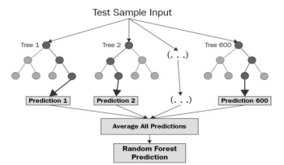

Fig: 1.1 - Working of a random forest algorithm

2.1.2.4 Linear Regression
This type of supervised learning is used in cases where the data used is continuous and is used to predict real-time values like total sales etc. In this algorithm, a relation between independent and dependent variables is set by fitting the best line called regression.

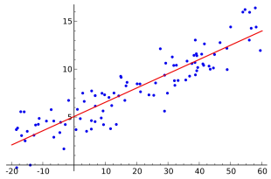
Fig: 1.2 - Working of Linear Regression

2.1.2.5 Decision Tree
This type of supervised learning is used for both categorical and continuous data but it is mainly used for classification problems. Here the data is split into various groups or sets based on different distinct independent variables. Based on the score the best is set of the independent variable is chosen.

School of Computer Engineering, KIIT, BBSR

NAME OF PROJECT

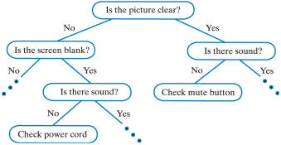

Fig: 1.3 - Working of Decision Tree

2.1.2.5 SVM
In this algorithm, plot n-dimensional space (where n is the number of features you have) with the value of each feature being the value of a particular coordinate. Then some lines are drawn in between the 2 different classified groups. The line from which the 2 closest points from both the groups are the farthest is selected.
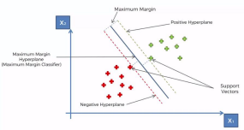
Fig: 1.4 - Working of SVM
2.1.2.6. XGBoost Regressor

Ensemble learning involves training and combining individual models (known as base learners) to get a single prediction. XGBoost is an ensemble learning approach for building supervised regression models. The validity of this statement is often inferred by knowing about its (XGBoost) objective function and base learners. An objective function consists of aloss function and a regularization term. It states the difference between actual values and predicted values, i.e the error in predicted values. The most common loss function in XGBoost for regression problems is reg: linear, which for binary classification is reg: logistics. XGBoost expects to possess the bottom learners which are uniformly bad at the rest so that when all the predictions are combined, bad predictions are canceled out and a will invoice better one sums up to form final good predictions.

School of Computer Engineering, KIIT, BBSR

NAME OF PROJECT

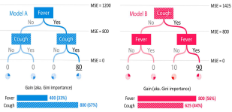

Fig: 1.5 - Working of XGBoost Regressor

2.1.2.4 JDBC

JDBC stands for Java Database Connectivity. It is an API for Java, which helps toconnect and access a database. It is used to retrieve, edit, add data to the database when calledfromthe UI by executing a query.
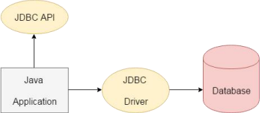

2.1.3 The idea behind the project

In the Machine Learning part of the project, we received an invoices dataset that contained the past payment information and behaviour of various buyers. Based on the previous payment patterns, the ML model had to predict what will be the date payment is made by the customer for an invoice. The model also predicts which ageing bucket the invoice falls into based on the predicted payment date. In the Web Development part, we parsed, processed, and loaded the given invoices dataset in the provided database schemas. A responsive UI is made which can display the invoice data loaded from the database. The UI supports searching and infinite scrolling operations. The UI supports editing of some editable fields, adding a new row to the grid, deleting rows from the grid, and downloading selected records from the grid in the predefined template(s).

School of Computer Engineering, KIIT, BBSR

NAME OF PROJECT

Chapter 3

Project Analysis / Project Implementation

2.1 Project Implementation

The implementation of the project can be broadly divided into two parts:
3.1.1 ML - Data analysis and Modelling: Data analysis and modelling mainly deal with, studying and understanding the underlying patterns of the data, structuring the data, and building some kind of model to estimate the future outcomes based on novel data. Applying machine learning models to make predictions in business contains two parts: formulating a quantitative model for the business problem and tailoring the machine learning algorithms on the formulated model. Although little work has been done on predicting the outcomes of business invoices, there exists a large amount of analysis that has been performed on the accounts receivable to get a clear picture of the data. In the remaining parts of this section, I will review all the analyses performed and the classic machine learning specifically supervised regression algorithms used here.

3.1.1.1 Problem Formulation
In this project, we ask two questions about a new business invoice when giving instances of historical invoices and outcomes: " Would the invoice payment delay or not? " If it would delay, how long the delay would be? To answer these two questions, we will invoice payment delay, build a regression model that predicts the number of days by which it will get delayed, based on a training set of data containing instances whose outcome is known. We formulate the invoice outcome prediction task as a supervised learning problem: given instances of past invoices and their outcomes, build a model that can predict when a newly issued invoice will be paid, if no advanced actions are taken. And this model shall help us understand the characteristics of delayed invoices and problematic customers. In other words, it doesn't not only identify the payment delay but also evaluates the customers.

School of Computer Engineering, KIIT, BBSR

NAME OF PROJECT

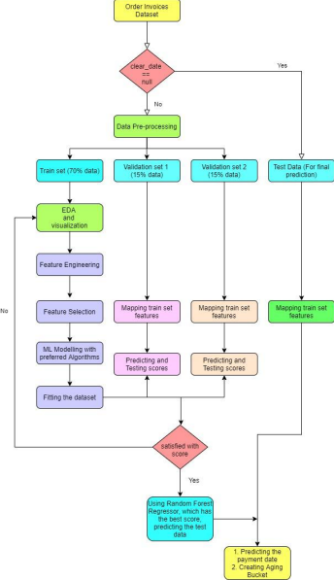
Fig: 1.7 - Working of ML Model

School of Computer Engineering, KIIT, BBSR

NAME OF PROJECT

The dataset consisted of 50,000 rows, from which 4094 rows did not have the attribute‘clear_date’. These observations (samples) are considered in the testing set. The other portion of the dataset is divided into training and two validation sets. All the date-related attributes are converted to DateTime format. The supervising attribute or the target variable is named‘label’, which interprets the number of days of invoice payment delay. It is calculated by subtracting the due_in_date from the clear_date in terms of days. The training set consistedof32134 observation data and the two validation sets consisted of 6886 observations each.

3.1.1.3 Analysis of the Features

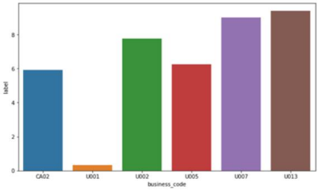
Fig: 1.8 - Average delay for customers from different business codes

The above barplot identified the average delay for customers from different business codes. Here we can see the customers from business code U001, make the minimum delay, and the customers from U013 make the maximum delay.

School of Computer Engineering, KIIT, BBSR

NAME OF PROJECT

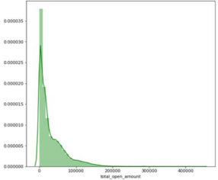
Fig: 1.9 - Total_open_amount distribution curve

- From the first plot, we can observe that most of the open amount is in between 0- 100,000 i.e. very less number of customers are there whose high amounts are pending
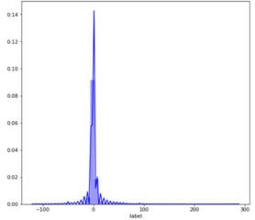
Fig: 1.10 - Delay Distribution Curve
- From the second curve, we can observe, most of the customers delay for a periodmostly between 0-50.

School of Computer Engineering, KIIT, BBSR

NAME OF PROJECT

3.1.1.4 Feature Engineering
The feature engineering has been done separately for train and validation set data. All theencodings have been performed over the train set and have been mapped to the validation&test set data. Some of the feature engineering steps have been pointed out below:
● Converting the currency to the same unit (USD), as there are few transactions inCADand few in USD, so there can be unnecessary weighting of observations due tothemultiplying factor between USD and CAD. The conversion is done with the helpofthe formula: USD = CSD/0.78
● Label encoding business_code, doc_type
● Mapping number of average delayed days per customer
● Target encoding cust_number, customer terms, this gives us more informationabout the nature of a specific customer id in delaying the invoice payment.
● Extracting the days, months, and quarters from the dates.

● Heat map: A heat map (or heatmap) is a data visualization technique that shows themagnitude of a phenomenon as color in two dimensions. The colorvariationWedisabled maybeWedisabled by hue or intensity, giving obvious visual cues to the reader about how the phenomenon is clustered or varies over space.

3.1.1.6 Modelling (Supervised Regression Learning)
Before modeling the validation set has been divided into two sets –
● val1 – for hyperparameter tuning
● val2 – for testing the accuracy of the model on unseen data For modeling, we have considered 5 models namely –
● XGBoost
● Decision Tree
● Gradient Boosting
● Random Forest
● Light Gradient Boosting

NAME OF PROJECT

3.1.2 Java + ReactJS - application development: The application development part is
related to building a web-based application that consists of a frontend dashboard displaying
the data in a tabular form with different options like add, delete, edit and predict, connected
to a backend database. We have created a beautiful user interface to add, edit, delete, print,
and most importantly, predict order invoices with ReactJS. For this we have followed certain
Step
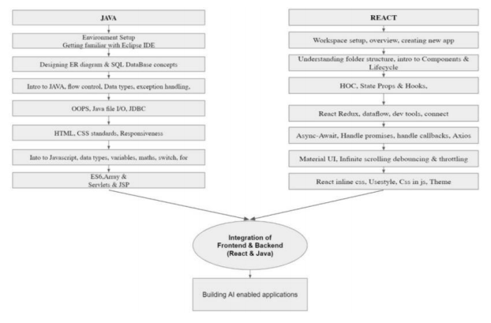

Fig: 1.14 - Workflow of Java and ReactJS

3.1.2.1 Loading of Data in the Database
The data was loaded in the database using SQLYOG and all tables and queries were created
and successfully displayed. This was done by creating a raw CSV reader module from scratch.
This module can read CSV files and can process the data to input into the database with the
help of the JDBC Driver class.

3.1.2.2 Creation of the Backend
The backend portion was done in Java. The first JDBC connection was established with SQL.
Then servlets were created for every functionality
● Add servlet - POST request from the frontend with parameters such as invoice
amount, notes, date, etc and pass them to the SQL database to add a new order to the
database
● Edit Servlet - POST request from the frontend with parameters such as doc_id to
identify the invoice in addition to the parameters which need to be changed.
● Delete Servlet - Delete the selected invoices from the database, by passing their
respective doc_id’s to identify them in the database.
● Search Servlet - Get the invoice number from the frontend and pass them as an HTTP
request and search through the database and return it to the frontend again.
● Data Display Servlet - Display the table of invoices to the frontend UI.

School of Computer Engineering, KIIT, BBSR

NAME OF PROJECT

3.1.2.3 Creating a Responsive Dashboard
A responsive dashboard was made in React Js. The main page had a Head Section, composed
of the company logo and account name logo, and then the Grid Section, consisting of a panel
having Add, Delete, Edit, and search button. The Predicted Payment Date will remain blank
and selecting one or multiple rows and then clicking on predict will get the payment date
populated. Whenever multiple rows are selected the add button will remain activated and the
user can type in the value he/she wants to insert. Also, the user has to fill all the required
fields otherwise insertion won’t happen. Clicking on the edit button permits the user to edit
all the editable columns, but only when one row is selected.
With the help of the delete button, the user can delete one or more pre-existing data.
The search button helps to look for particular data. The View Correspondence button will
help to print the invoices of one or more orders. All these functionalities were carried out by
using material-UI and establishing a connection with the backend.

3.1.2.4 Flask Integration
Finally, integration of the ML model was done with help of the flask module. First,
one .pickle file was generated then using some lines of python script flask integration was
done. As same as the servlet used as an API for the functionalities, for the prediction also
some POST request was made using this .pickle file.
And finally, the project is complete

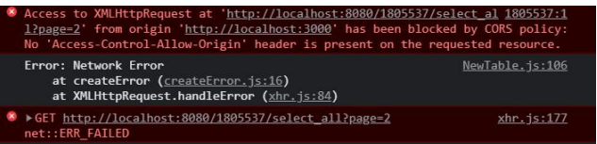

This happens when we want to access cross origin requests. As the frontend UI is running on
localhost:3000 port, but the backend servlets are running in 8080 port, browser does not
allow this cross origin request. So we have to explicitly switch on this service via this chrome
extension. Now we can run our project.

Chapter 4

4.1 Results & Discussions

4.1 Machine Learning Model Results (Back end)

The final accuracy for all the models on the training set, validation set 1, validation set 2 have
been listed in the table below.
As the ‘Random Forest’ yielded the highest accuracy in the table, so we selected this
algorithm for predicting the training dataset, which we have already segregated at first, the
data with ‘clear_data’ == null.

NAME OF PROJECT

15 days then it will be placed in bucket1 if the delay is more than 15 days and within 30 days
then it will be placed in Bucket 2 and so on.
After categorizing the data we are creating a new column in our dataset (Aging bucket) and
storing the bucket list in that column for further reference.
After the modelling was done, we stored the best model (with the Random Forest Regressor)
in a .pkl file, so that we can use this file when we’ll predict the result.

4.2 Java & SQL (Backend)
As the ML part was done, we started filling our databases with the present data (i.e.
from .CSV). But we cannot put the raw data into the database, so we made a CSV reader
from scratch to preprocess the raw data and make it, database readable.

So we automated the process with code and the above was the result. Now, as this part was
done, we started with creating the Add, Edit, Delete and Search servlets. We created the
servlets using JDBC and servlet mapping was done, so that we can call each servlet uniquely
List of Servlets:
● http://localhost:3000/select_all - fetch all data
● http://localhost:3000/add - add data to database
● http://localhost:3000/edit - edit one order
● http://localhost:3000/delete - delete orders
● http://localhost:3000/view_data - for view correspondence
● http://localhost:3000/search - searching data

4.3 Web Application Results (Frontend)
Here is the directory structure of the VS Code or the frontend part.
● action folder is used to place the action function for setting up the redux store.
● assets folder contains all the images and the CSS files.
● component folder contains the main UI structure of the application. For ex. - header portion, middle grid portion, tables and all the buttons which are
needed like Add, Edit, View Correspondence, Predict and delete. The UI of Search Bar is also
present.
● reducer folder contains the files needed for setting up the redux store.
● services folder contains all the API like “fetchAll”, “addDataAPI”, “editDataAPI”, “deleteDataAPI”, “viewDataAPI”, “prediction” and “search”
● utils contains all the utility functions, constant values, invoice printing code and theme set up.

The main UI page consists of the HighRadius logo in the upper middle, the company logo in
the upper left corner, and the required buttons in the next subsequent portion and at last, the
table UI which contains the dataset.

If one row is ticked, then we can do Predict, View Correspondence, Add, Delete, Search
operation, but cannot do edit operation, as we cannot edit two orders parallely.

School of Computer Engineering, KIIT, BBSR

NAME OF PROJECT

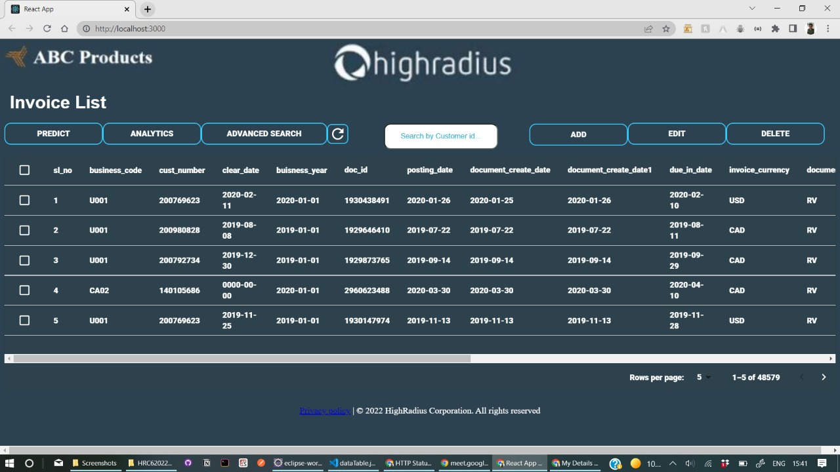

Edit Button Functionality: Clicking on the edit button will allow the user to modify the
editable fields in the data. The editable columns are Invoice Amount and Notes. The edit
button will remain in a disabled state by default. When the user selects one row, the Edit
button gets enabled. If a user selects multiple rows, the edit button will remain disabled.
Clicking on the Edit button displays a popup window on the screen. The window should
contain the Invoice Amount and Notes headers along with a Cancel and a Save button. The
user should be able to edit the values. Once the user clicks on the save button, the new values
should be displayed in the UI and should remain persistent.

Delete Button Functionality: Clicking on the delete button will allow the user to delete one
or multiple data. The delete button will remain in a disabled state by default. After the user
adds ticks to a minimum one row, the delete button gets enabled. The window should contain
a Cancel and a Delete button. Once the user clicks on the Delete button, the values should be
deleted in the UI and should remain persistent.

Predict Button Functionality: Clicking on the predict button will allow the user to predict
the probable payment Date for one or multiple data. The predict button will remain in a
disabled state by default. After the user adds ticks to a minimum one row, the predict button
gets enabled. The window should contain a Cancel and a Download button. On clicking the
Download button, a file containing the data from the selected rows in the selected template
should be downloaded in PDF format. The PDF would look like this.
Flask server was setup in pycharm IDE for the convenience purpose. First we have created a
virtual environment for the same to install extra libraries that we need for the purpose, like
flask library for the local server, joblib for loading the pickle file and others.
The local server address was set up to be http://127.0.0.1:5000/predict to be used for the flask
server.

School of Computer Engineering, KIIT, BBSR

NAME OF PROJECT

Chapter 4

Conclusion & Further Work

5.1 Conclusion
During the tenure of my training at HighRadius, I had exposure to various technical
languages which helped in shaping my analytical and problem-solving skills as well as
provide knowledge that could be applicable in real-time projects as well. By making the
Order Management System I was able to learn how a flow of code works and how to
establish connections between different languages.
5.2 Future Work
With the help of AI-Enabled Fintech B2B Order Management Application the organizations,
companies, and in fact, individuals can keep track of the payment of their orders irrespective
of a large number of clients. This will not only reduce time but also provide a functional
manner for the proper functioning of an organization and/or workplace.
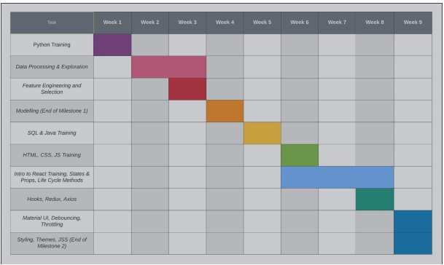
Fig: 1.27 - Gaant Chart for project planning and management

School of Computer Engineering, KIIT, BBSR

REFERENCES
[1] Various articles on https://towardsdatascience.com
[2] https://www.tutorialspoint.com/servlets/index.htm
[3] https://www.w3schools.com/react/showreact.asp?filename=demo2_react_test
[4] https://www.javatpoint.com/machine-learning
[5] https://www.javascripttutorial.net/
[6] https://openliberty.io/guides/rest-client-reactjs.html
[7] https://docs.python.org

